**【ISIC - International Seminar on Investment Casting】**

The ISIC has been served as a premier platform where could carry the latest notions and researches of the investment casting. With the discussion and exchange during seminar, the international academic communication and cooperation would be enhanced.

The 10th ISIC will be held in Taichung/Taiwan on 13th~15th November, 2019. It is also a great pleasure for TFS (Taiwan Foundry Society) to be the host again of this great event.

**Let’s show you the foundry industry in Taiwan possesses the following traits:**

**. Outstanding capability for producing various superalloy materials.**

**. Fast design responses to manufacturing processes.**

**. One-step supply chain via an integrated production system.**

**As the host, we are sincerely welcome you to join 10th ISIC in Taiwan and share**

**your viewpoint with us as well as enjoy the beautiful landscape.**

**Date: 13th~15th November, 2019**

**Place: Nan Shan Education & Training Center (ETC)**

**─No. 300, Chenggong W. Rd., Wuri Dist., Taichung City, Taiwan─**

**On-Line registration:** [**https://ppt.cc/fZgmvx**](https://ppt.cc/fZgmvx)

|  |  |
| --- | --- |
| **Date** | **Program** |
| 13th Nov.  (Wednesday) | Industrial Visit Tour |
| 14th Nov.  (Thursday) | Expo,  ISIC Keynote Speech, Oral Presentation,  Welcome Party |
| 15th Nov.  (Friday) | Expo  ISIC Oral Presentation,  TFS Annual meeting,  Gala Dinner |

**【ISIC Seminar Program】**

1.Place：ETC –1F Hall 101

2.Note：Admission by the delegate badge.

Taiwan Foundry Society reserve the right to correct the program.

Mandarin/English/Japanese, simultaneous translation.

3.Content：

| Date | Code/  Page | Time | Topic | Lecturer |
| --- | --- | --- | --- | --- |
| 11/14 Thu. |  | 09:00-17:00 | Registration | |
|  | 13:00-17:30 | ISIC-EXPO | |
| (TW) | 13:00-13:20 | Opening | Chairman of TFS: Chiu-Feng Lin  Chairman of Committee: Solas Y.J. Lin |
| M1  (TW) | 13:20-13:40 | Taiwan Investment Casting Market trend | Jing-Shiang Shih – secretary-general /Taiwan Foundry Society  Chief Casting Technology Section / Metal Industries Research  Development Centre/Metal Processing R＆D Development  施景祥秘書長-台灣鑄造學會 |
| M2  (US) | 13:40-14:00 | North American Market for Investment Castings Trends and Outlook | Joseph E. Fritz - Executive Director / ICI (Investment Casting Institute) |
| M3  (EU) | 14:00-14:20 | European Investment Casting Market Review | Carlos Olabe - Executive Director / EICF  ( European Investment Casters ́Federation ) |
| M4  (EU) | 14:20-14:40 | Global Market Outlook 2019 | Ronald Williams- Managing Director / The Blayson Group Ltd UK |
| M5  (JP) | 14:40-15:00 | Market Trend of Japanese Investment Casting Industry | Yukio Nasu 那須 征雄- Japan Foundry Society / Nasu Technology Consultant office |
| M6  (CN) | 15:00-15:20 | The Investment Casting Market of Chinese Mainland in 2018 | Zhang Yun- secretary-general /Investment Casting Branch of China Foundry Association  張耘秘書長-中國鑄造協會精密鑄造分會 |
|  | 15:20-15:40 | Coffee Break | |
| K1  (TW) | 15:40-16:25 | Fabrication of Three Dimensional Structures In Polymer-Based Micro channels with Lost-Wax Casting | Chunhui Chung - Associate Professor,  Department of Mechanical Engineering  National Taiwan University of Science and Technology  鍾俊輝教授-成大機械系 |
| K2  (TW) | 16:25-16:10 | A Specialty Refractory Blend that Builds High Performance Primary Slurries and Improves Casting Defects | Lin Bing-Hao - Engineer / President Co., Ltd.  林稟豪工程師-忠正(股)公司 |
| T1  (JP) | 16:10-16:40 | Method of measuring ash content for investment casting wax | Yosuke Saito - Product Engineer /Taenaka Kogyo co.,ltd. / Investment Casting Production Dept |
| T2  (US) | 16:45-17:15 | The advantage of high-quality process control and automation in the wax room and the benefit to all downstream operations. | Chris Boylan - MPI, Inc. |
| T3  (EU) | 17:15-17:45 | The Progression of Investment Casting Wax Technology Through Time. | Ronald Williams -The Blayson Group Ltd UK |
|  | 18:30-20:00 | Welcome Reception | |
| 11/15  Fri. |  | 09:00-13:00 | Registration | |
|  | 09:00-16:00 | ISIC-EXPO | |
| T4  (TW) | 08:30-09:00 | Wax Technology Through Time  A Study of Rapid Prototype of Investment Casting using 3D Printing Ceramic Mold (3DPCM) Technology | Dr. Ching-Tsai Wu - Senior Project Manager/  Metal Industrial Research & Development Centre  吳慶財博士-金工中心熔鑄組 |
| T5  (JP) | 09:05-09:35 | Advanced 3D printing  Technology for Ceramic  Cores and Fused Refractory  Materials | Koichiro Nabetani 奈部谷 光一郎 - AGC Ceramics co.,Ltd. |
| T6  (JP) | 09:40-10:10 | Permeability of ceramic shell mold. | Ryosuke Naito 内藤 亮佑 - Permeability of ceramic shell mold IHI corporation /Material Processing Gr. |
| T7  (EU) | 10:15-10:45 | The use of advanced materials technology to improve shell room efficiency | Gavin Dooley – REMET UK, Ltd. |
| T8  (JP) | 10:50-11:20 | Investigation on the high temperature strength characteristics of shell mold | Shusaku Sagara - Manager /CASTEM CO.,LTD / Business Development Dept. |
| T9  (JP) | 11:25-11:55 | Ultra-High-Speed Casting Simulation 「JSCAST」 | Minori Yasoda -QUALICA Inc. JSCAST ofiice |
|  | 12:00-13:00 | Lunch | |
| T10  (TW) | 13:00-13:30 | Jewelry material–present and future | Dr. Lung-chuan Tsao - Professor /National Pingtung University of Science and Technology,Graduate institute of Materials Engineering  曹龍泉教授-屏科大材料工程研究所 |
| T11  (TW) | 13:35-14:05 | Application of investment casting on cast iron cookware | Dr. Solas Lin – President/ Solas Science & Engineering Co., Ltd.  林允進總經理-般若科技(股)公司 |
| T12  (TW) | 14:10-14:40 | Influence of Iridium on the creep properties and phase evolution of Mar-M247 fine-grain superalloy | Dr. Jian-Hong Liao - Engineer /National Chung-Shan Institute of Science and Technology /Metallurgy Section, Materials and Electro-Optics Research Division  廖健鴻博士-中科院 |
|  | 14:45-15:00 | Coffee Break | |
| T13  (CN) | 15:00-15:30 | Construction and Application of Digital Investment Casting Innovation Platform | 周建新教授 – 華中科技大学 |
| T14  (EU) | 15:35-16:15 | Application of Ind 4.0 on Investment Casting : Smart Service of IC Process and Equipment | J.N.Byrne - Director&Chairman / VA Technology Ltd |
| T15  (TW) | 16:20-16:50 | Introduction of Robot Intelligent Manufacturing Cell and Application of Grinding and Polishing | 施志軒研發經理 - 工研院機械所 智慧機器人技術組 |
|  | 17:00-17:15 | Closing Ceremony | |
|  | 18:30-20:30 | Gala Dinner | |

4.Entry fee：

|  |  |  |  |
| --- | --- | --- | --- |
| **Category** | **Status** | **Fee(USD)** | **Contents** |
| ISIC Registration | Member | 400 | * Participation in the conferences * Proceeding w/E-file * 14th Nov. Welcome Party * 15th Nov. Lunch * Souvenir |
| Non-Member | 800 |
| Welcome Party | Member | 40 | Dinner of 14th Nov. |
| Non-Member | 70 |
| Gala Dinner | Member | 60 | Dinner of 15th Nov. ，Banquet |
| Non-Member | 120 |

* The fee of Expo & Plant Tour are exception.
* You shall be liable for all relevant bank transfer fees.

**【ISIC Industrial Visit Tour】**

1.Visiting Date：13th November 2019 (Wednesday)

2.Deadline of application：20th October 2019 (Besides until the participant full)

3.Note：The industrials have the right to winnowing the participant and ask for exchange visit.

4.Fee：100USD (Including Bus、Lunch、Group Insurance、Mineral Water)

5.Route：

|  |  |
| --- | --- |
| Route **A** | (1)Chia Yeh Precision Casting CO.,LTD. (chiayeh-casting.com.tw)  (2) Chips Investment Casting Inc. (www.chips-casting.com) |
| Route **B** | (1) Solas Science & Engineering Co., Ltd. (http://www.solas.com )  (2) Fusheng Precision Co., Ltd. ( https://www.fusheng-precision.com/ ) |

**【ISIC-EXPO】**

1.Time：14th November (Thursday) 13:00PM ~ 17:30PM (10:30AM for Move-in and decoration)

15th November (Friday) 9:00AM ~ 16:00PM

2.Place：ETC –1F Hall 102

3.Booth arrangement：

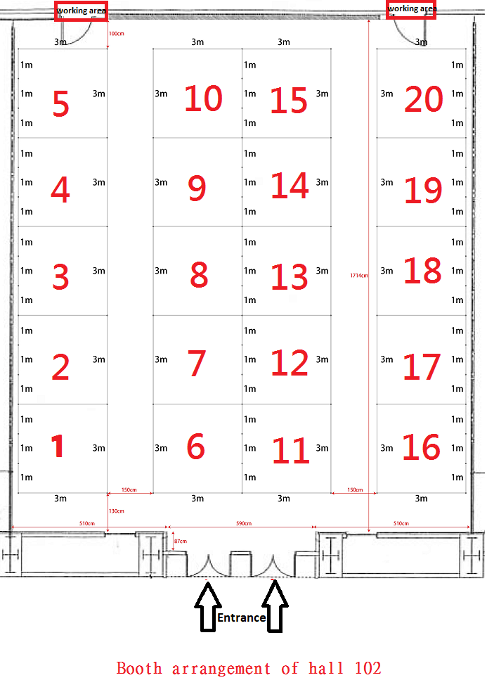

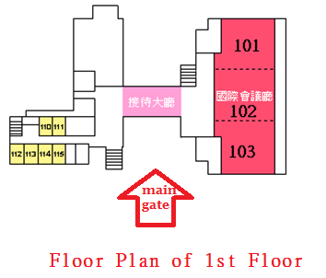

**Occupied**

**Occupied**

**Occupied**

**Occupied**

**Occupied**

**Occupied**

**Occupied**

**Occupied**

4.Registration：(Before 15th August 2019 or full registration)

|  |  |  |  |
| --- | --- | --- | --- |
| **ISIC EXPO REGISTRATION** | | | |
| Company name | (It’ll show on the booth) | Boss |  |
| Contact person |  | E-Mail |  |
| ADD |  | TEL |  |
| FAX |  |
| Membership & price | □Member USD$1,660 □Non-member USD$2,330元  Belong to which association - ___________________________________ | | |
| Booth No. | 1st selection： ；2nd selection： ；3rd selection： | | |
| Note | **1.Prices are for 2 days exhition. Booth size is 3x3x2.5m with back board； 5A/110V power socketx1、table(with tablecloth)x1、chairx2.**  **2. 1 person for Free Registration ISIC seminar and gala dinner. And one standard double room of Freshfields Resort(www.freshfields.com.tw/).**  3. Please send back the filled form to Taiwan Foundry Society. And remit the amount by the following payment method. The booth you selected will be held under the complete payment.(You shall be liable for all relevant bank transfer fees.)  Bank transfer  Please Payable to  MEGA INTERNATIONAL COMMERCIAL BANK CO.,LTD，  NEW YORK AGENCY (SWIFT：ICBCUS33, CHIPS NO.908 OR FEDWIRE ROUTING NO.026009085) FOR CREDIT TO MEGA INTERNATIONAL COMMERCIAL BANK CO., LTD TREASURY DEPT (UID NO.321402) IN FAVOR OF  **MEGA INTERNATIONAL COMMERCIAL BANK CO., LTD，KAOHSIUNG METROPOLITAN BRANCH**  **A/C NO：002-53-02155-5**  **A/C NAME：Taiwan Foundry Society**  4.Contact us：Taiwan Foundry Society / Samira Yang  TEL：+886(0)7-3534791 FAX：+886(0)7-3524989 E-Mail：foundry@seed.net.tw | | |

**【ISIC Sponsorship proposal】**

|  |  |  |  |  |  |  |
| --- | --- | --- | --- | --- | --- | --- |
| **Amount(USD)**  **Content** | **680** | **1,000** | **1,700** | **2,400** | **3,350** | **5,000** |
| Free registration (1person)note1 | 1 | 1 | 2 | 2 | 4 | 4 |
| Gala dinner (1person) |  | 1 | 2 | 2 | 4 | 4 |
| Freshfields Resort  (Double/1 room/2 breakfast) |  | 1 | 1 | 1 | 2 | 2 |
| ISIC-Expo  (1 booth) |  |  |  |  |  | 1 |
| TAKU ironware – Iron pot |  |  | 1 | 1 | 1 | 1 |
| TAKU ironware – Tea pot |  |  |  |  | 1 | 1 |
| Publicity Materialnote2 |  |  |  | V | V | V |
| Sponsor Logo Exposure and link on TFS Webnote3 |  |  |  | V | V | V |
| Sponsor Logo Exposure on the cover of the 「Proceeding」 |  |  |  | V | V | V |
| Normal Advertisement in the「Proceeding」  (A4 size/1 page/color) | V | V |  |  |  |  |
| Thick insert advertisement in the 「Proceeding」  (A4 size/1 page/color/only 6 page) |  |  | V |  |  |  |
| Advertisement inside bottom of the 「Proceeding」  (A4 size/1 page/color/only 2 page) |  |  |  | V | V |  |
| Advertisement on bottom of the 「Proceeding」  (A4 size/1 page/color/only 1 page)  **Occupied** |  |  |  |  |  | V |
| Sponsor Logo Exposure on the banners and indicator boards |  |  |  | V | V | V |
| Sponsor Logo on the banners of registration and platform  (3 sponsors limited) |  |  |  |  | V | V |
| Sponsor Logo on Seminar bag  (3 sponsors limited) |  |  |  |  | V | V |

Note：

* 1、ISIC Free registration includes Participation in the conferences, Proceeding w/E-file, 14th Nov. Welcome Party, 15th Nov. Lunch, Souvenir.
* 2、Publicity Material provided by sponsors and will be put into meeting bag.
* 3、TFS Web-site : [www.foundry.org.tw](http://www.foundry.org.tw)

Continue link till 1st Jan. 2021.

* The sequence of the advertisement page according to the amount of

direct sponsorship.

|  |  |  |  |  |
| --- | --- | --- | --- | --- |
| **ISIC Sponsorship Application Form** | | | | |
| Company |  | | Boss |  |
| Contact |  | | E-Mail |  |
| ADD |  | | TEL |  |
| FAX |  |
| Amount(Pls Check) | * 680 USD | * 2,400 USD | | |
| * 1,000 USD | * 3,350 USD | | |
| * 1,700 USD | * 5,000 USD | | |
| * Other:______________USD | | | |
| Note | 1.Send out the invoice after received application form  2.Provide the E-file of advertisement with 300DPI，before 2019/Aug.30th  3. You shall be liable for all relevant bank transfer fees. | | | |
| Contact us | Tel: +886 7-3534791~2  Fax: +886 7-3524989  E-Mail: [isic.twn@gmail.com](mailto:isic.twn@gmail.com)  [foundry@seed.net.tw](mailto:foundry@seed.net.tw) | | | |

**【Organizer】 【Joint Organized】**

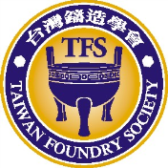   

**【Co-organized】**



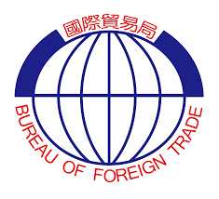**【Sponsor】**



**台灣鑄造學會**

**Taiwan Foundry Society**

**TEL: +886-7-353-4791~2**

**FAX: +886-7-352-4989**

**E-Mail: isic.twn@gmail.comisic.twn@gmail.com**

[**foundry@seed.net.tw**](mailto:foundry@seed.net.tw)

**Website:** [**www.foundry.org.tw**](http://www.foundry.org.tw)